Bright future in Gungahlin
Common Ground Canberra is the latest innovative approach to tackling homelessness in the ACT. Due to open in Gungahlin in June, Common Ground will be home to 20 people who have experienced chronic homelessness and 20 people on low to moderate incomes. In addition to the 40 one-bedroom fully self-contained apartments, the building also contains a large communal kitchen and recreation area, art space, computer work stations, outdoor BBQ area and community garden. The building will also have a 24 hour security presence on-site.
Partners in the project are Northside Community Service, which will provide Tenancy Support and Argyle Community Housing which will manage both the property and the 40 tenancies.
The project has also brought together many community partners. The ACT and Commonwealth Governments have worked closely with the Common Ground Canberra Board of Directors. Local businesses have generously supported the project including IKEA who have fully furnished 20 apartments. The Snow Foundation, Pandora’s - St Phillips Church, Canberra Quilters, Scouts, Orana Steiner School, Uniting Church Gungahlin and Country Women’s Association NSW, Alleasing, and Winning Appliances are also among the organisations generously supporting Common Ground Canberra.
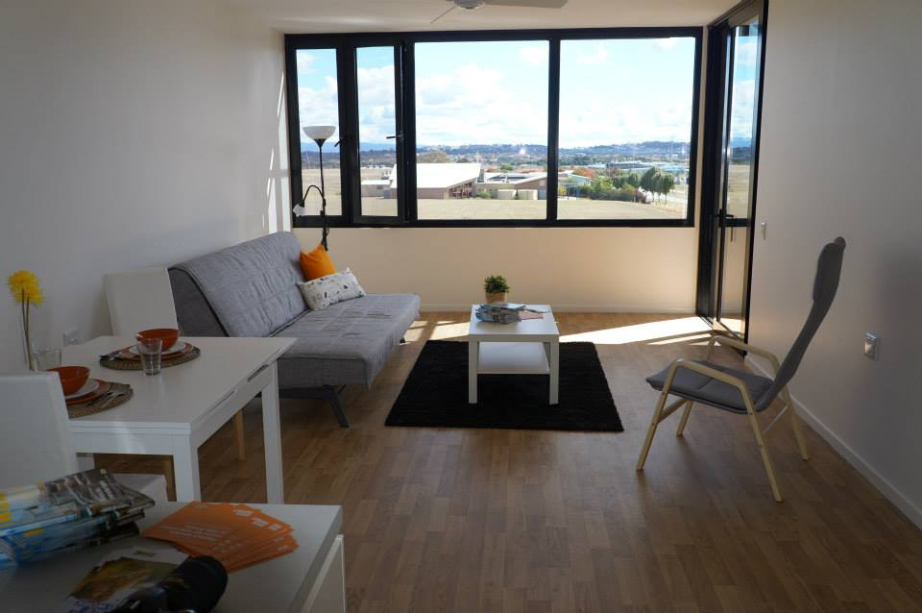
One of the beautiful apartments furnished by IKEA. The apartments are light and airy and come with individual balconies and have a minimum 6-star energy rating.
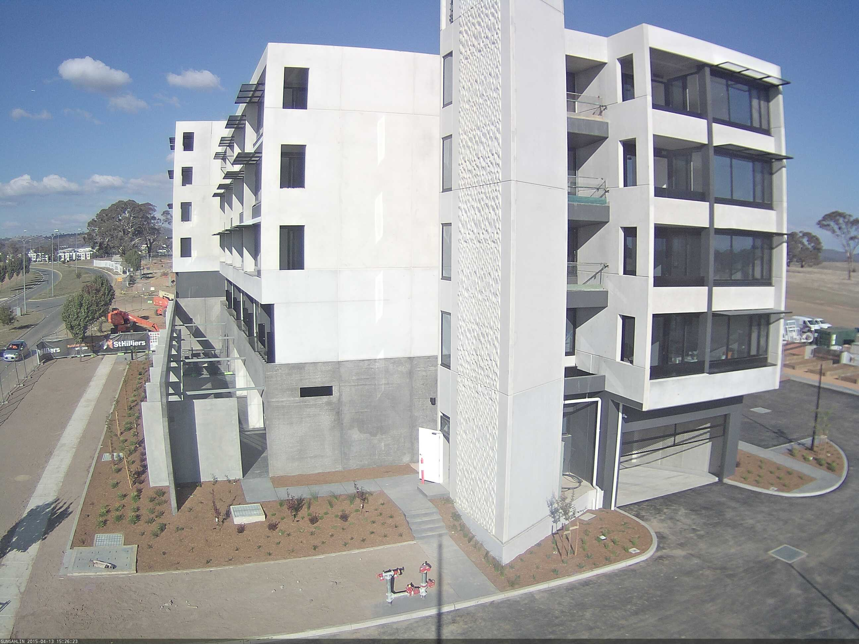
The brand new five storey building is just a short walk to the Gungahlin town centre and will be ready for its first tenants in June.
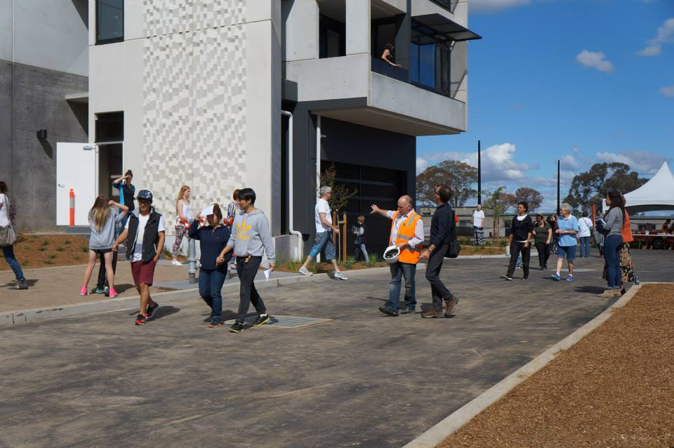
The Open Day on 11 April attracted a lot of interest from locals.

